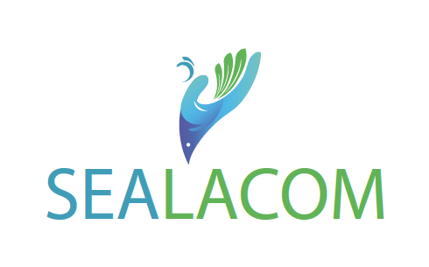
Call for mobility (Young PhD/Postdoc/Innovators)

This call is open to Lebanese doctoral students, young PhD holders, and innovators who wish to pursue training or a technical visit to an Italian institution.
- Expected date of the mobility’s end: 10 March 2024.
- Eligibility conditions for participation: Lebanese doctoral students enrolled in a PhD program without any other financial support for doctoral mobility in Italy, PhD holders interested in undertaking short post-doctoral training in Italian research institutions, young innovators and entrepreneurs seeking to undergo training or a technical visit in an Italian institution, incubator, or accelerator.
- Topics Covered: Food Security and Resilience, Food-Water-Energy and their NEXUS; Marine Environment, Risk and Crisis Management and Mitigation of Environmental Risk.
- Budget: ranging from 800 to 1 200 euros.
- Application deadline: November 15, 2023.
- Complete application should be emailed to enjeim@cnrs.edu.lb ; imane.abbas@cnrs.edu.lb with the subject line “SEALACOM-PhD/Postdoc/Innovator-mobility”

I. CANDIDATE SUMMARY
Civil Status

Full Name

Date of Birth

Address
Phone number

Email
Diploma
Baccalaureate

Bachelor
Master 1
Master 2
Engineering diploma
PhD
If already obtained, define the defense date:
If not, define the excepted defense date:

II. PhD DESCRIPTION (if applicable)
General Information
Title
Field
Abstract _{(do not exceed 300 words)}
Thesis Directors
Lebanon | Name  Institution
Abroad | Name  Institution
Current Institute(s) Description
1. Name
Affiliated institution
Responsible person
Phone number
Website and/or Social Media Handles:
2. Name
Affiliated institution
Responsible person
Phone number
Website and/or Social Media Handles:

III. IDENTIFICATION OF THE SCIENTIFIC MISSION
General Information

Title
Field
Duration of mobility
Abstract _{(do not exceed 300 words)}
Context and motivations _{(do not exceed 300 words)}
Objectives _{(do not exceed 300 words)}
Economic and social repercussions _{(do not exceed 300 words)}
Host Institute Description
Full name
Affiliated institution
Director
Phone number
Website and/or Social Media Handles:
Host Researcher Description
Full name
Phone number
Email

Signature of candidate:

Date

IV. DOCUMENTS TO PROVIDE

1. Application form completed and signed
2. Motivation letter
3. Curriculums vitae
4. Invitation letter from the director of the host institute
5. Copy of the last obtained diploma
6. Copy of the extract of civil status
7. For PhD students, a letter from thesis directors in Lebanon/abroad allowing them to do mobility in an abroad institute.
8. For PhD holders (if employed), a certificate from the current institution justifying the role of the fellow.

